Mission Space Lab Phase 4 report

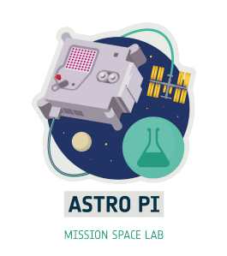

Team name: Atlantes
Chosen theme: Life on Earth
Organisation name: Niubit
Country: Spain

1. Introduction
Our work this year focused on developing techniques to locate specific elements in the photos with the idea of making a video with superimposed augmented reality elements. During the research we focused on locating population centers with more than 100,000 inhabitants, but the techniques developed can be used to locate any element whose position is known.
In previous years' projects we have observed several problems associated with the photographs. For example the orientation of the AstroPi camera when taking the pictures is indeterminate. The position (lat/lon) of the ISS obtained during the experiment is considerably far from the center of the photo. Finally, the characteristics of the orbit make that each photograph is rotated with a different angle with respect to the usual orientation of the maps (there are several projection systems to draw maps, but we are going to work with the de facto standard WGS 84 common in Internet map services).
For future experiments where it is important to correctly place elements of the Earth's surface in the photos, we have seen that we need to address this issue in order to master the situation.
2. Method
Our Astro Pi IR program, during phase 3, collected every 10 seconds all possible sensor data and the position of the station which it recorded in a CSV file. This year we really only needed latitude, longitude and altitude, but as always we took the opportunity to record data from as many sensors as possible, in order to have more data samples for future projects.
Our code also recorded photographs of the Earth with the VIS camera during the insolation phases of the ISS orbit.
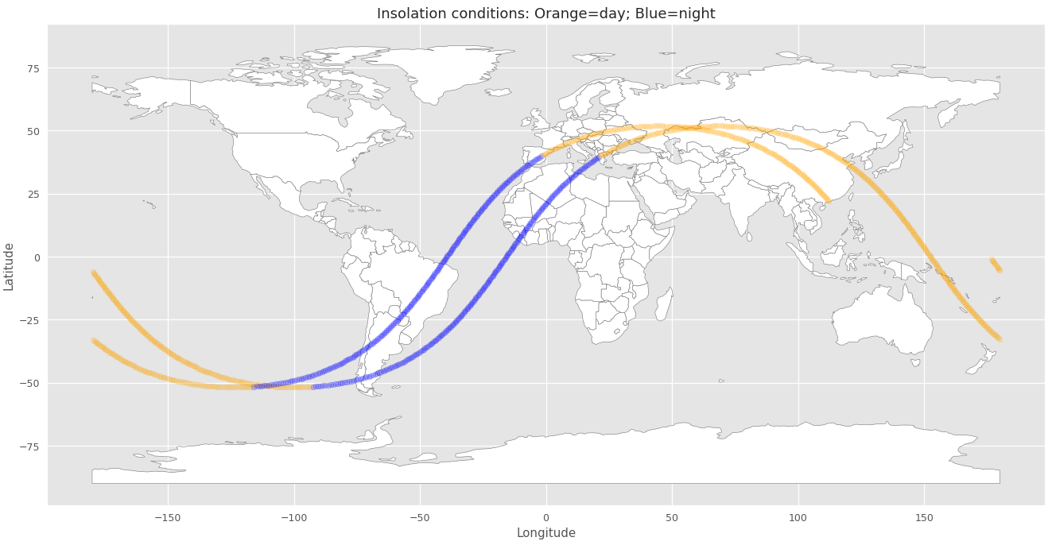Figure 1: Orbit
Both the position data collected in the CSV file and the photographs were processed using a Jupyter notebook with Python libraries such as 'pandas', 'geopy' and 'opencv'. In the notebook you can find all the details of the whole calculation process that we had to develop to correctly orient and geoposition the photographs.
3. Experiment results
In view of the orbit followed by the ISS, we chose the range of photos between 950 and 1069 during which Europe and Asia were flown over.
First we had to learn how to rotate the photos to correspond to the usual orientation on the maps (north up). We found that there are two angles that we had to know about
- α: variable during the orbit and directly related to it
- β: constant and corresponding to angle of displacement between two pictures
By developing geometric calculations we were able to determine these angles and rotate all the photos to fit the usual orientation of the map services.
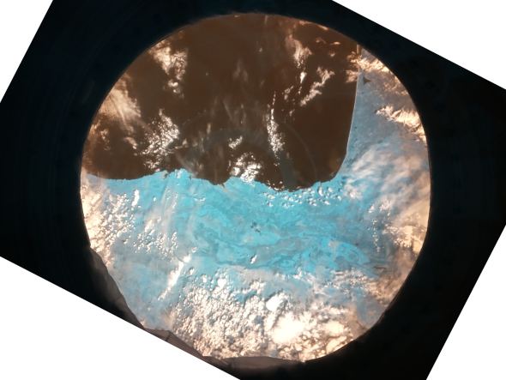Figure 3: Orientation corrected by calculation
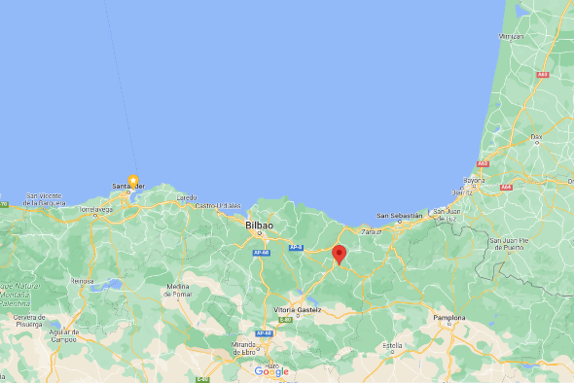Figure 2: Usual orientation on maps of the area

The next thing to solve was to determine the coordinates of the center of the photos, since we found that the lat/lon position we collected with the program was systematically displaced by 72km, which cannot be neglected. In Figure 4 we see the following points:
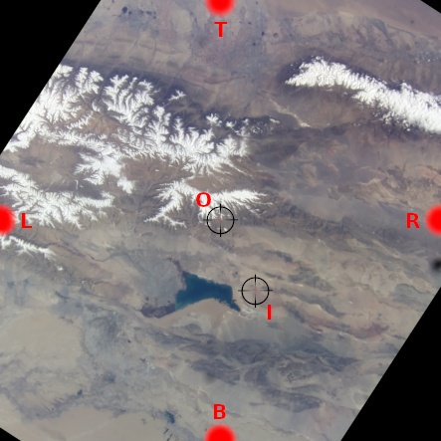Figure 4: Desplazamiento de posición centro
- I: Position AstroPi determined for the ISS at the time the photo was taken.
- O: Center point of the photo
- B, T, R, L: Photo ends to be used for georeferencing the photo
By means of geometry we determine these points for each photo, and from them by linear interpolation we are able to locate with sufficient precision any element from its coordinates. For example in Figures 5 and 6 we can see the southeast corner of Lake Bosten (China).
The next step consisted of drawing on the photos using OpenCV the cities with more than 100,000 inhabitants that we obtained by filtering a database containing their coordinates.
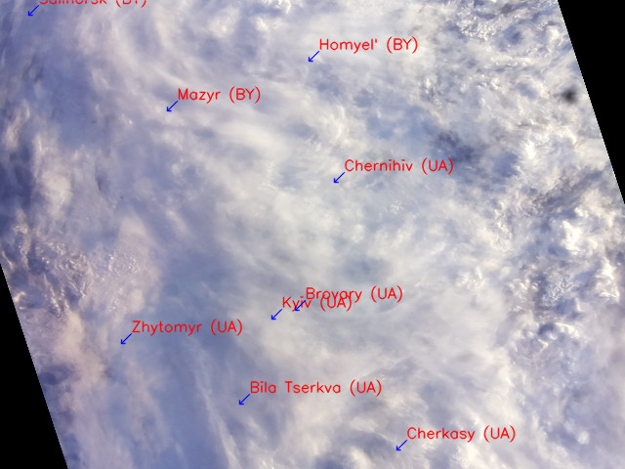Figura 1: Figure 7: Ciudades de más de 100.000 habitantes
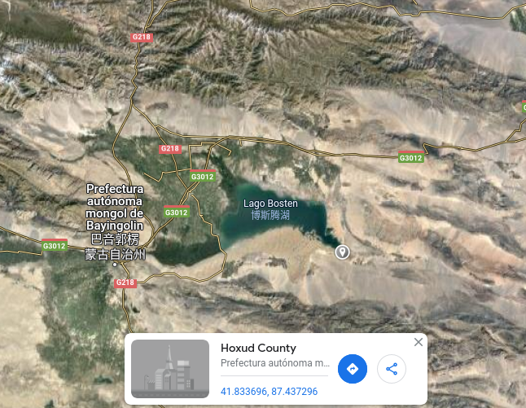Figure 5: Actual position
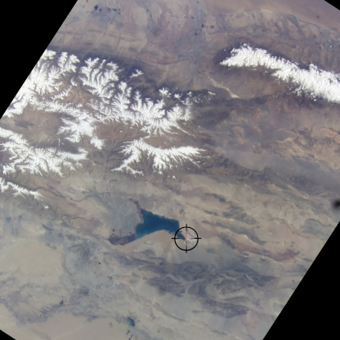Figure 6: Calculated position
Figure 7: Cities with more than 100,000 inhabitants
All the analysis was done with Python code on Jupyter with the notebook that can be found here: https://github.com/niubit/astropi_atlantes_2022-2023
Finally, the video with the final product can be seen here: https://youtu.be/ulbvDoxAtUU
This link to Google Colab allows you to view the notebook directly:
https://drive.google.com/file/d/16GmYvto7nTvwt1k91wB4xtj5O_W37Co7/view

4. Learnings
As lessons learned from this project, we highlight the spatial reasoning skills that we had to develop in order to correctly georeference the photos in a way that allowed us to accurately represent elements on them.
It was necessary to seek help since the mathematics involved were beyond our reach. But as our tutor showed us, it is part of engineering to know how to find the resources needed to solve problems. It was very interesting to see how such a problem can be solved with some ingenuity and a few new calculus concepts.

5. Conclusion
As an overall conclusion we can point out that perhaps the challenge proposed this year was too ambitious. On the one hand, we have not been able to add the voiceovers in the different languages by means of algorithms. Due to lack of time we have made a manual simulation incorporating them into the video by editing.
Also, as mentioned in section 4, the mathematics needed to georeference the photographs were beyond our reach. When we were well advanced in the way we used, we realized that there might be alternative ways to solve or approach the problem, but we made this reflection too late and it was no longer worth looking back. Possibly this will be a new learning experience for future projects.
In any case, we are satisfied with the way things have happened, with the work done and with the final result.

